|  |  |
| --- | --- |
|  | PAG Manager User Manual |
|  |  |
|  | Jacques Eluecque  Written for PAG Manager Version 1.5 |

This User Manual will help you configure, navigate and effectively use the PAG Manager application. This manual is split into 2 sections, Basic functions and Administrative functions. Administrative functions involve modifying core settings and initial setup of the software. The Basic functions will not work until the software has been set up.

Contents

Basic Functions

Awarding a PAG to students 2

Viewing and modifying a specific students record 2

To view PAG or Skill records 3

Creating a student Report 4

Export to Excel 4

Administrative Functions

Obtaining a copy of PAG Manager 5

Updating PAG Manager 5

Enabling Admin Mode 6

First time setup 6

Creating a Preset 7

Adding Students 10

To manually add students 10

To add a list of students in bulk 10

Changing student details 11

Moving classes or years of students 11

Exporting and Importing data 12

Very Advanced Function

Advanced File Manipulation 13

# Awarding a PAG to students

Go to the Award PAG Tab. Select which class or individuals to award the PAG too. If you select a class then unchecked students will be marked as absent. If just students are selected then other unchecked students will be unaffected. Select PAG's on the right that they have completed. Any unchecked skills will be marked as failed for that PAG for all selected students. Select the date and then click award PAG to award the PAG.

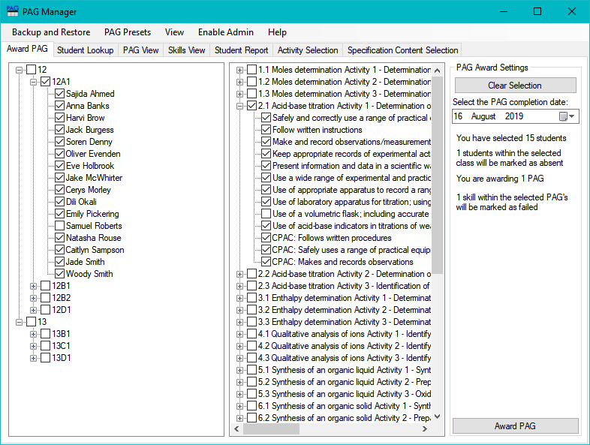

# Viewing and modifying a specific students record

Go to the Student Lookup tab and select the student that you wish to view. You can enter search for names and look up students that have been archived. Click on a student to start modifying it.

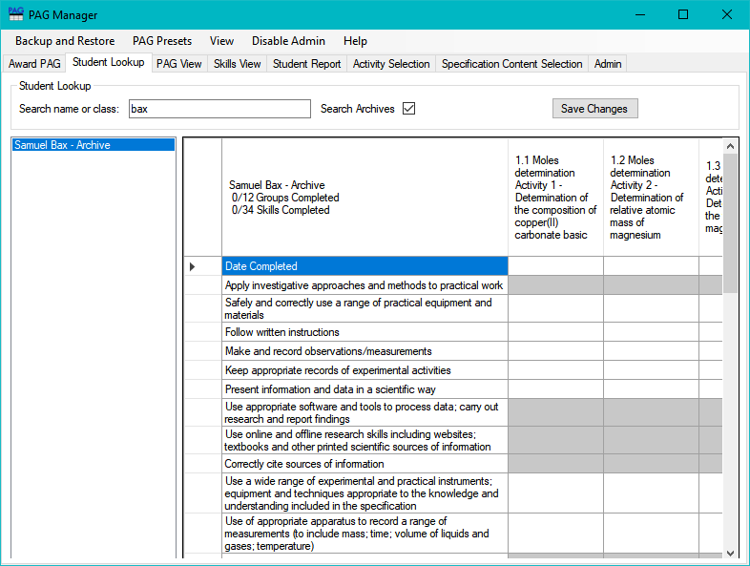

To award a PAG to a student, enter the date they completed it under the PAG. To mark the student, write the letter ‘a’ or absent in the date completed box to mark it as absent. You can press the delete key to remove any records. You can also change a specific skill within a PAG to achieved, not achieved or absent.

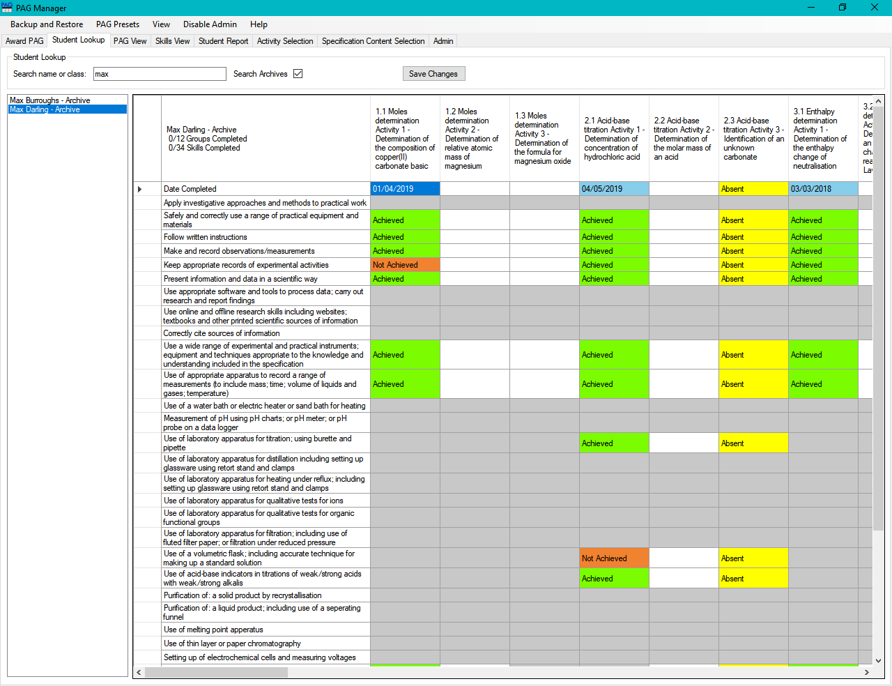

# To view PAG or Skill records

Open the PAG View or Skills View tab. The PAG view tab shows which students have completed which PAG's and which dates they were completed. There is also an option to hide the PAG's for which no student has done the PAG. This can be useful to hide PAG's which are never done by the school. There is also a filter at the top so that individual classes or students can be filtered out

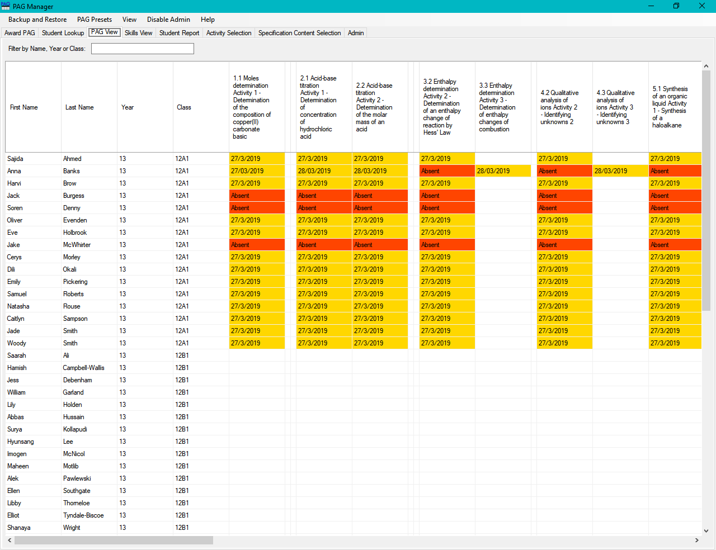

# Creating a student Report

To create a student report go to the student report tab and click the “generate report” button. This will show a list of all students with their current condition. This will show which If they have passed, if they are missing any PAG groups or which skills are missing if all PAG groups have been achieved. Clicking a condition will list all the PAG's required to complete all the skills at least once, although the list may not be the most efficient way to complete all PAG's. You can also filter conditions using the buttons on the right hand side.

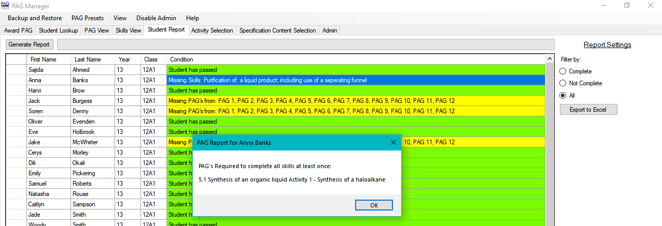

# Export to Excel

To export a list of which PAG's need to be completed by which students, go to the Student Report tab and click “Export to Excel”. After inputing a save location the excel file will be made and automatically opened. It should look like this:

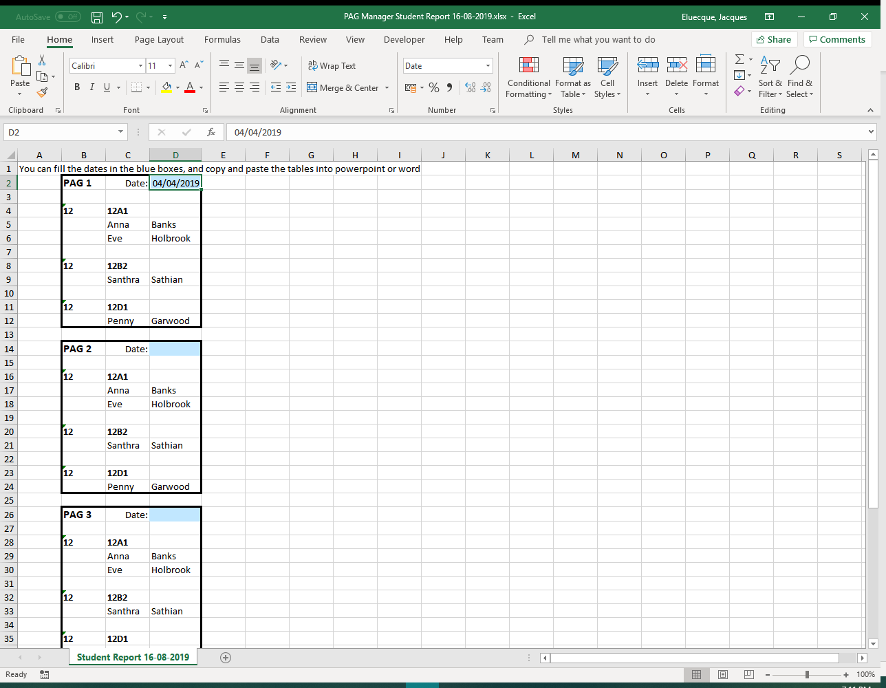

This lists every PAG group which needs to be completed by students, and which students need to do those PAG's. You can input the date that the PAG will be taking place in the blue box. You can also select the tables and copy and paste them into another application such as Microsoft PowerPoint or Microsoft Word and then print out the tables to display on walls, or send out to classes

# Obtaining a copy of PAG Manager

The latest version of PAG Manager can be obtained at the GitHub page for the project located here: <https://github.com/Jacques2/PAG-Manager/releases/latest>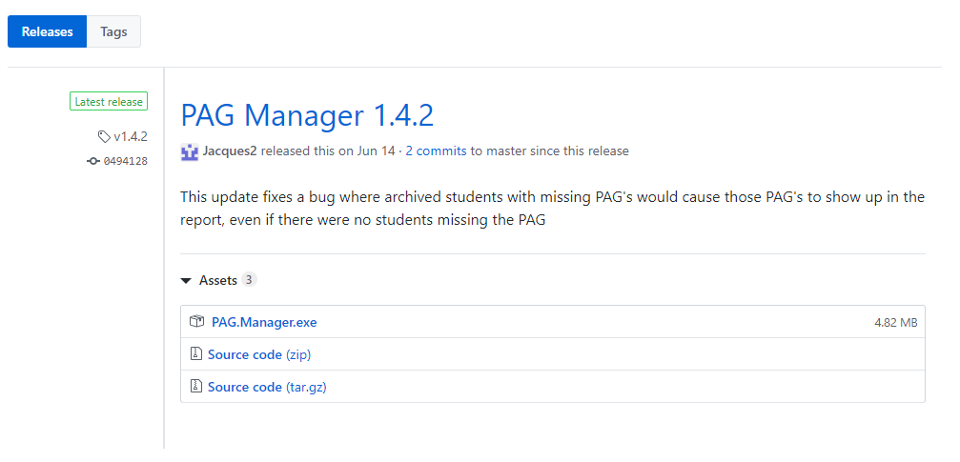

Click on PAG.Manager.exe under Assets (circled in above diagram) to download the program. Move the file to the location where you want the PAG Manager to be installed. It is recommended that this file is put inside its own folder as it will create additional files. Putting this file in the shared staff drive allows other teachers to access and modify PAG's. Opening this file will start the first time setup.

# Updating PAG Manager

To check which version of PAG Manager is currently being used click on “Help” on the toolbar and then click about. You should then see a box like this with the version number.

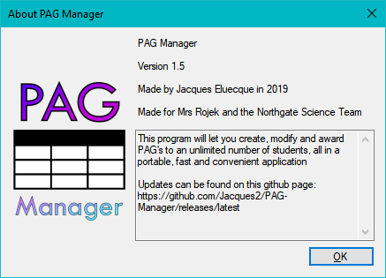

Visiting this link will show the most recent version of the software. Updates may be released in future to fix any issues with the program.

Link: <https://github.com/Jacques2/PAG-Manager/releases/latest>

Follow the same instructions as the “Obtaining a copy of PAG Manager” section but delete the old PAG.Manager.exe file before copying the new one across.

# Enabling Admin Mode

When performing administrative tasks admin mode will need to be enabled. You can do this by clicking “Enable Admin” on the toolbar of the program. If admin mode is already enabled, then the button should say “Disable Admin” instead. Enabling Admin only applies to you until the program is closed or the disable admin button is pressed.

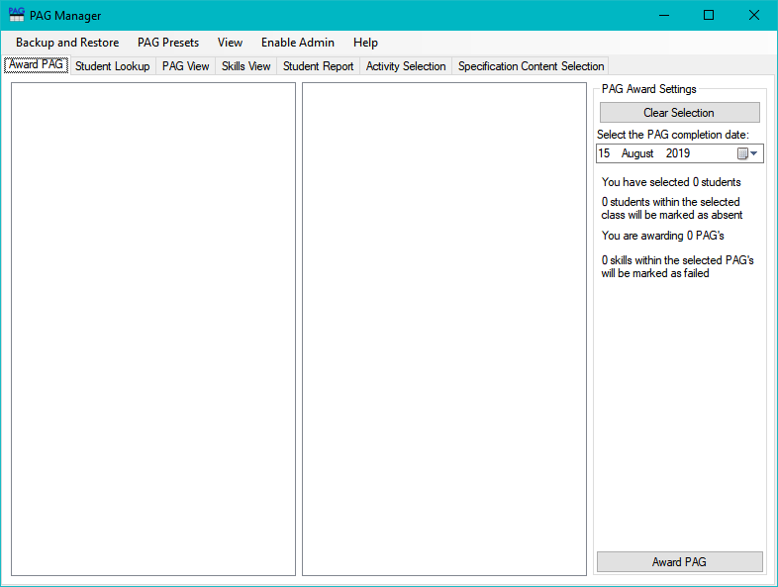

# First time setup

When you first open the program some additional files will be created in the same folder that the program is in. The program should look like this:



This program can be used for PAG’s in any subject as long as they follow a certain structure. A “Preset” contains all the information about PAG's for a subject. They contain all the PAG's in the course, all the practical skills in the course, and which PAG's contain which skills.

If you are planning on using this application for OCR A-Level Biology (H420), OCR A-Level Chemistry (H432) or OCR A-Level Physics (H556) then presets have already been created for these subjects. If this is being used for other sets of PAG's you will have to create a preset. Go to the “Creating a Preset” section for more information.

To use an already created preset first click “Enable Admin” button on the toolbar of the application and click ok on the message box. Click on the admin tab and then click on the “Other settings” sub-tab. Then click on the “Add Default Presets” button. Now Presets for biology, chemistry and physics have been added.

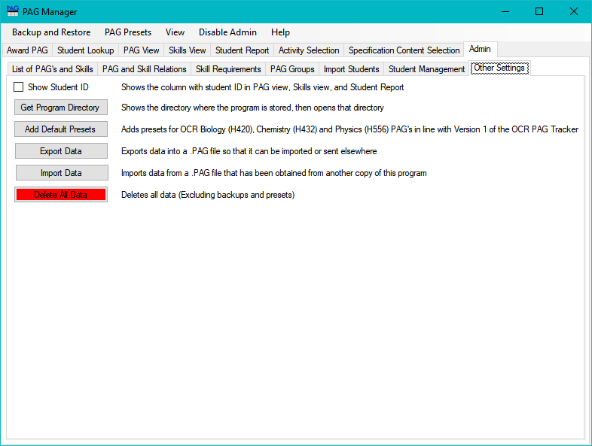

To access these presets click on the PAG Presets option in the toolbar, then click “Load PAG Preset” and select the preset you wish to use. After selecting a preset the screen should look like this:

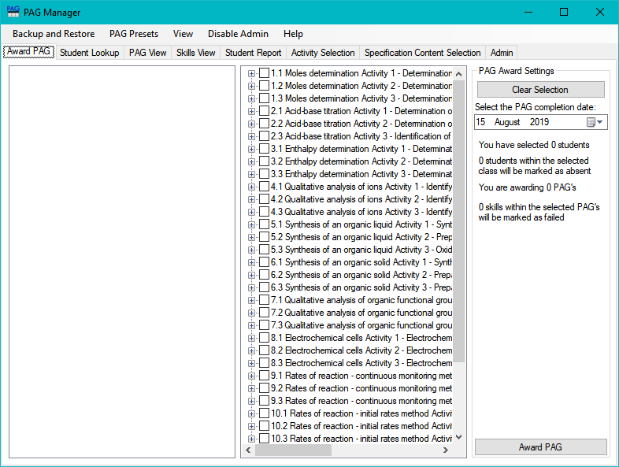

# Creating a Preset

If you are planning on using this application for OCR A-Level Biology (H420), OCR A-Level Chemistry (H432) or OCR A-Level Physics (H556) then presets have already been created for these subjects. If this is being used for other sets of PAG's you will have to create a preset.

Make sure Admin mode has been enabled, then go to the admin tab. Creating a preset takes 4 steps:

Step 1: Go to the “List of PAG’s and Skills” tab within the Admin section and you should see a screen like this.

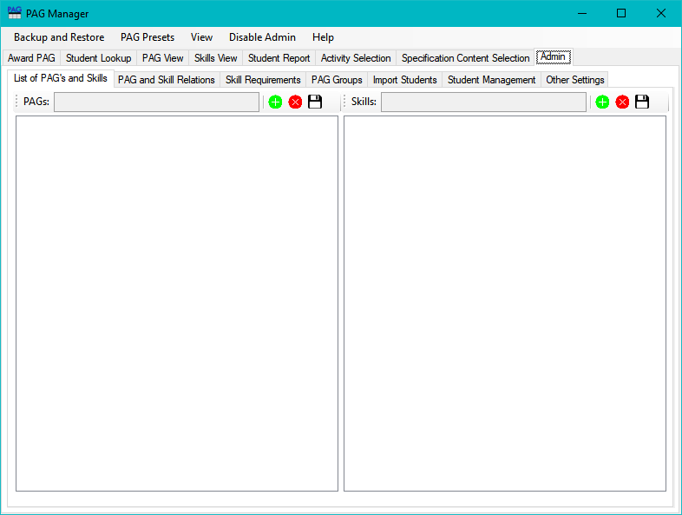

To add a PAG click on the (+) button on the left side and fill in the name of the PAG. Clicking the (x) button will remove the currently selected PAG. When all of the PAG's have been filled in make sure you save the data or it will be lost. Repeat the process with the skills until all of the PAG's and skills have been added

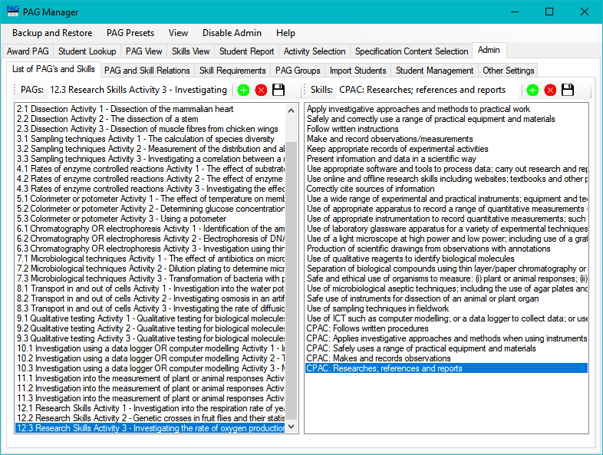

Step 2: Go to the “PAG and Skill Relations” tab. Click on a PAG on the left side and then check all of the skills on the right side which are used in the PAG. Go through this for every PAG and then click “Save PAG-Skill” Relations

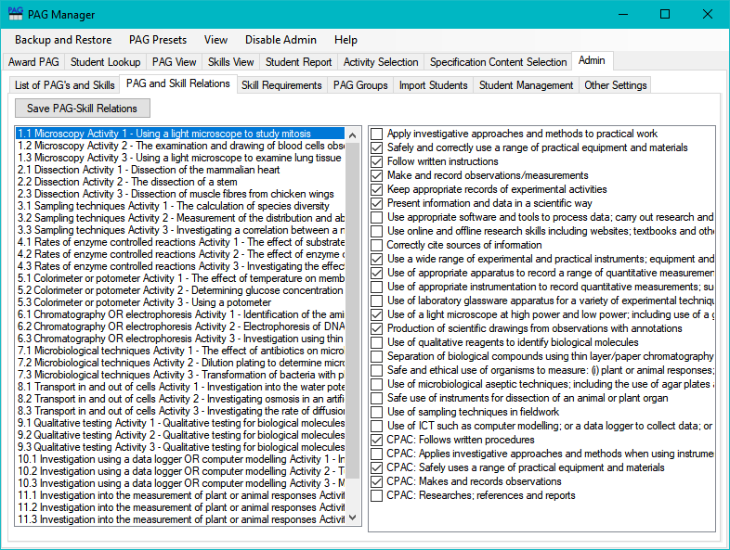

Step 3 (Optional): Click on the Skill requirements tab. By default each skill only has to be shown once by a student to show that they are proficient in that skill but this can be changed if required.

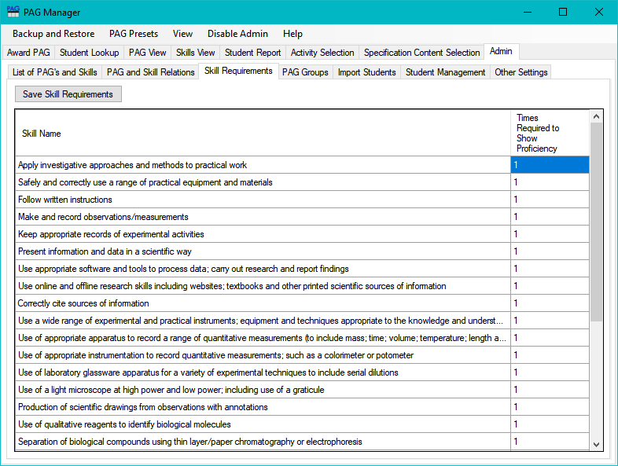

Step 4: Click on the PAG groups tab. This tab allows you to create groups. Each student is expected to complete AT LEAST 1 PAG from each group. You can create or delete groups on the left and assign PAG's to those groups on the right.

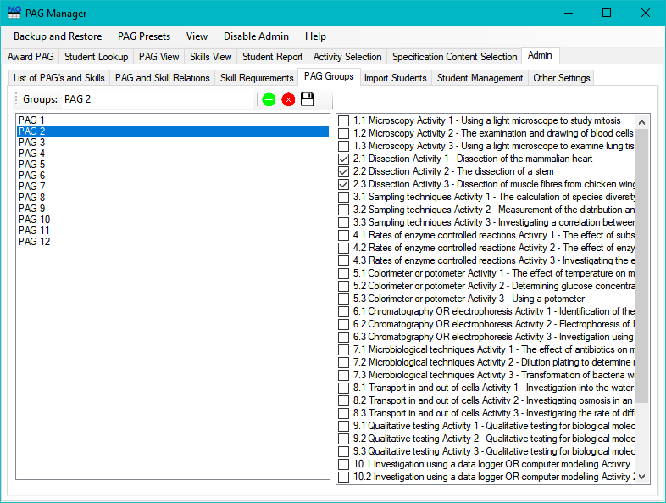

# Adding Students

Students can be added manually into the system or imported from another application such as Capita SIMS in a **CSV** file. To add students make sure admin mode is enabled.

## To manually add students

Go to the “Student Management” tab within the “Admin” tab and click Add Student. A student will be created and you can fill in the information about the student.

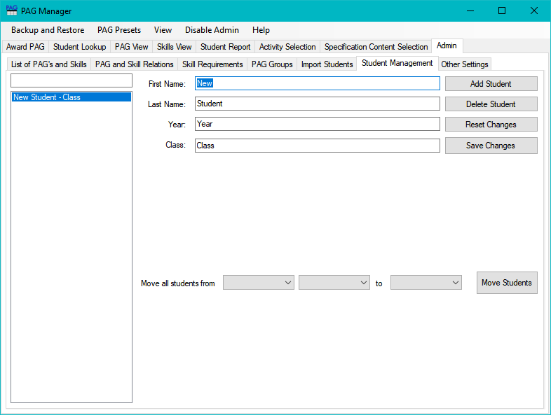

## To add a list of students in bulk

This program will accept a list of students from a CSV file. Programs such as SIMS by Capita will allow you to export to csv by creating a report under Report>Design Report>Create a new report. The csv will need 4 columns with First name, last name, year and class. Once the CSV file has been created go to the “Import Students” tab within the admin tab and click “Import CSV”. Select the CSV file you wish to use and it will be imported into the program.

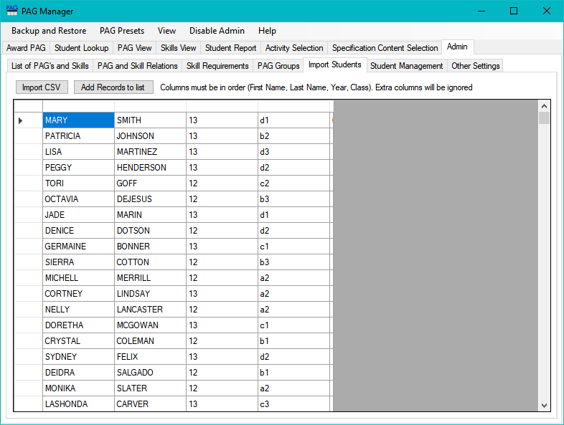

Once the csv file has been imported, check that it has been imported correctly. Columns can be rearranged from the headers so that they are in the correct order. Make sure that any additional columns that are not necessary are dragged to the end so that they are ignored. Any incompatible record will be replaced with the word “invalid” so check through the records to make sure that everything has been imported. Cells can be modified to change any information. Once everything has been checked click on the “add records to list” button

# Changing student details

To change student details, go to the student management tab within the admin tab. Select the user you wish to modify. There is a filter box which allows you to search for a specific student. After selecting the student you can modify all of their details, delete the student, or archive the student by renaming their class or year to “archive”

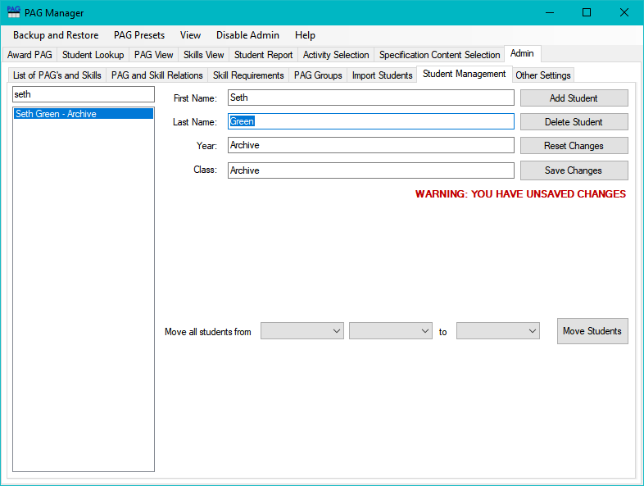

# Moving classes or years of students

At the end of the school year, all students will be in a different class. There is a way to bulk move every student between classes. Go to the student management tab within the admin tab. At the bottom of the screen there are 3 boxes that can be used to move students. This can be a bit confusing so if something goes wrong you can press the reset changes button to reset what has been done.

If you have a year 12 class moving into year 13 and a year 13 class that needs to be archived, you would need to work backwards. You will need to move all students from year 13 to archive, then move all students from year 12 to year 13. If you move students from year 12 to 13 first, then all year 13 students to archive then every student would end up in the archive so you need to work backwards.



The first box selects whether you are moving a class or a year group.

The second box selects which group you are moving.

The third box selects what new group is being moved too.

After the year 13 students have been moved to archive the year 12 students need to be moved to year 13. As there are no year 13 students currently in the system, a new year will have to be specified.

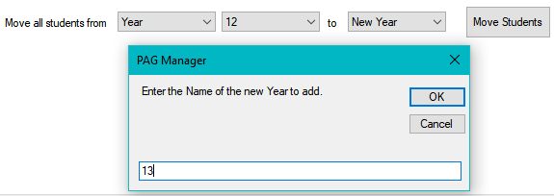

This will move all the year groups for the students but classes will remain the same. The same process can be used to move the classes.

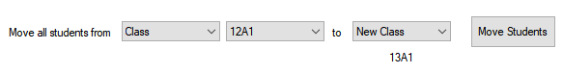

# Exporting and Importing data

If you wish to export the current data to a file so that it can be imported into another copy of PAG manager go to the Other Settings tab within the Admin tab and then select Export Data or Import Data. Exporting data will allow you to pick a location to export the .PAG file to. Importing a .PAG file will add it as a backup which can be loaded at any time.



# Advanced File Manipulation

This section will cover file and folder structure for the program for automation or debugging. If you are trying to work out how to use the program, you are in the wrong place.

In the directory of the exe there will be 2 folders that contain information, SaveData and Presets. Inside the SaveData folder will be a folder called Current which is the data currently being used by the program. All additional folders are user created backups. Saving and Loading backups just moves the contents of one folder into another. Inside each folder are 7 csv files. Much to the horror of my computer science teacher, this program relies on csv files. File structures for all the files are listed below:

|  |  |  |  |  |  |
| --- | --- | --- | --- | --- | --- |
| File Name | Column 1 | Column 2 | Column 3 | Column 4 | Column 5 |
| PagList.csv | Ascending Numerical Unique PAG ID | Plain Text name of PAG, commas replaced with semi-colons |  |  |  |
| SkillList.csv | Ascending Numerical Unique Skill ID | Plain Text name of skills, commas replaced with semi-colons |  |  |  |
| SkillRequire  ment.csv | List of all Skill ID’s | Integer of times required to show proficiency in skill |  |  |  |
| PagGroup.csv | Ascending Numerical Unique group ID | Plain Text name of groups, commas replaced with semi-colons | All PAG's part of the group are placed in up to an unlimited number of extra columns, 1 per PAG | | |
| StudentReco  rd.csv | Ascending Numerical Unique student ID | Plain Text first name of student, commas replaced with semi-colons | Plain Text last name of student, commas replaced with semi-colons | Plain Text year of student, commas replaced with semi-colons | Plain Text class of student, commas replaced with semi-colons |
| PagSkillRelati  on.csv | ID of PAG | ID of Skill within a PAG | Position of skill within PAG (used for PagAchievement) |  |  |
| PagAchievem  ent.csv | ID of Student | ID of PAG student has completed | Date PAG was completed | List of 0’s (completed) 1’s (not completed) and 2’s (absent). The position within the number string correlates to column 3 within PSR |  |

Presets contain backups just without student information and PSR